"Beyond Boundaries: Unleashing 6G's Transformative Wave in India"
Shivek S Mittal¹
shivekmittalr@gmail.com

Abstract:
India is a developing country in terms of both technology and infrastructure. Since, India is already pursuing its research in 5G and is already using 4G network. But the problem that Indian citizen have with current mobile network infrastructure can’t be properly solved even by the upcoming of 5G so here we need to think about that why are we talking about 6G in too early stage. Not only because of great network bandwidth and low latency the features of 6G or why we say that 6G will be game changer for Indian mobile network infrastructure because of features like Maximum spectral efficiency that’s up to 1000km/hours and peak data rate that’s up to 1Tbps which is twice than that of 5G and nearly quadruple of 4G. In this paper we discussed about what are the main advantage. What are the problem faced by Indians, why these problem are caused and how 6G can solve these problem also we provide the questions that we asked from the people (mainly from the youth of India). In addition, our paper also suggests a project idea that provides a technological solution to teachers’ and professors’ wasted time at schools or colleges attending this conference.

Introduction:
In this technology-dominated world, the progress of wireless communication has indeed played an important role in shaping today’s world. To enable people experience the transformative benefits that 6G technology will bring to India; paving way for cross-border connectivity and innovative opportunity in traditional systems space (Singh et al., 2023). From 1G through to 5G: Journey; Exponential increases in speed, latency and connectivity (Srivastava & Singh, 2021). However, as we are now entering the era of 6G, discourse is shifting from alterations to changes that would redefine wireless communication itself (Mishra et al., 2023). The sixth generation is not just about velocity: It means a system beyond terahertz frequency, machine intelligence and holographic communications indicating indeterminate future of connectedness. No doubt, in a country as vast and diverse as India, the need for being ahead of others in telecommunications cannot be overemphasized (Joshi & Prakash, 2020). The road towards 6G is vital in tackling the unique problems and prospects of India’s technological odyssey. Nevertheless, this technology would have a profound impact on every Indian citizen from city dwellers to farmers living in remote areas (Kumar et al., 2023). However, by connecting all devices at all times through wireless connections that are even faster than we can imagine, it will open up new vistas for humanity (Yadav & Agarwal, 2021). How does the digital world look like in 6G era? This chapter seeks to explore the potential of 6G to change our perception of digital experiences ranging from augmented reality encounters to advanced machine applications (Sharma & Singh, 2022). For instance, with smart cities and industry four coming into play across India, one would not underestimate the necessity of connectivity provided by 6G to foster advancements across different sectors (Gupta et al., 2023) There is also an outline about how various aspects of Indian society may be reinvented using the expected applications of sixth generation network (Verma et al., 2021). Whether it's revolutionizing healthcare delivery, enhancing agricultural practices, or catalyzing economic growth through the Internet of Things (IoT), the versatility of 6G positions it as a cornerstone for addressing the evolving needs of a rapidly advancing nation (Sharma et al., 2020). Our paper have following sections:
First section is about what is the basic need of 6G or why we need 6G or what are the importance of 6G over other network. After these we discussed the challenges faced by people of India due to current network, which comprises of problem in sectors of health, finance, defence and education. Then we proposed the idea of how can we use 6G for attendance so that it can save time of both teacher and student. After this we listed all the questions asked in survey with graphical stats that we received. And at the end we concluded our all paper
Understanding the Need for 6G Technology:
As each new generation of telecommunication evolves, there are transformative breakthroughs (Smith et al., 2021). Although we are embracing 5G’s innovations today, 6G is already lurking on the horizon. Understanding what 6G technology needs necessitates a more subtle examination of the growing demand for an interdependent world as a whole (Jones & Patel, 2022). Apart from speed and connectivity, 6G imagines an era where never-before experienced levels of data exchange, ultra-low latency and novel applications will merge to redefine what is technologically possible (Brown & Lee, 2023). This dive into the world of 6G demands that we understand how changing connectivity and future developments in society or industry will shape our lives in yet unexplored patterns (Garcia & Wang, 2021). Some major reasons why there is high demand for it are as follows.
• Technological Advancements:
• Edge Computing Imperative:
• Internet of Things (IoT) Support:
• High Performance Computing (HPC) Nexus:
• Key Players in 6G Development:
• Global Research Initiatives:
• Country-Specific Involvement:
• Hexa-X and Global Collaboration:
• Academic Contributions:
Table 1:why do we need 6G (difference between 6G,5G and 4G)
Core concept | 4G | 5G | 6G
Peak data rate | 1Gbps | 10Gbps | 1Tbps
(E2E) end to end latency | 100ms | 10ms | 1ms
Maximum spectral efficiency | 15 bps/Hz | 30bps/Hz | 100bps/Hz
Mobility support | Up to 350 km/hour | Up to 500 km/hour | Up to 1000 km/hour
Satellite integration | NO | NO | fully
AI | NO | PARTIAL | FULLY
AUTONOUMUS VEHICLE | NO | PARTIAL | FULLY
XR | NO | PARTIAL | FULLY
HAPTIC COMMUNICATION | NO | PARTIAL | FULLY
THz communication | No | Very limited | Widely
Service level | Video | VR, AR | Tactile
Architecture | MIMO | Massive MIMO | Intelligent surface

Now since we have discussed about the advance feature of 6G so let move towards the problem faced due to the current network:
India being the second largest country with 496.50 million subscribers of mobile network had to face a large number of problems due to bad network bandwidth One of the major issues facing the Internet segment in India is the lower average bandwidth of broadband connections compared to that of developed countries.
(src: https://en.wikipedia.org/wiki/List_of_mobile_network_operators)
The basic problem that we discussed here that are faced due to current network in India are:
- Education sector
- Hospitals
- Financial sector
- Defence sector
Navigating Educational Challenges in India's Network Infrastructure: A Glimpse into the Potential Role of 6G
India's education system has completely changed with digital technologies. During covid crises all school and colleges were closed due to lockdown and were facing issues in online classes due to network infrastructure which puts the quality and access to education at stake. The most common problem faced by students during these time were:
- The limited connectivity of rural areas:
Students in rural area were facing a main problem due to less reach of network in those area As a result, this makes it difficult for students living in far flung locations to benefit from online educational resources and interactive learning experiences.
- Internet Bandwidth Limitation and Unreliable Connectivity:
In urban area the networks lagging and low speed of wi-fi resulting in the problem for online classes such as lagging of video during online classes or joining or rejoining of internet .
- Discriminatory Access to Educational Resources:
However, this leads to uneven opportunities for people belonging from different social-economic background since unprivileged ones lack equal chances of getting a good quality of education compared to their privileged counterparts who work under more advanced conditions (Sharma, 2019).
The Potential of 6G in Mitigating Educational Challenges:
- Ultra-Reliable Low Latency Communication (URLLC):
6G technology is expected to provide ultra-reliable low latency communication, ensuring seamless connectivity even in remote areas. This can significantly enhance the delivery of real-time interactive educational content and bridge the digital divide (Mahmood, Z., et al. , (2022). )
- High Bandwidth and Enhanced Data Rates:
The increased bandwidth and data rates offered by 6G can address the current limitations, allowing for high-quality video streaming, virtual reality (VR) experiences, and other data-intensive educational applications (Rappaport, T. S., et al. , (2021). ).
- Integration of Artificial Intelligence (AI) in Education:
6G's support for AI applications can revolutionize personalized learning experiences, adaptive assessments, and intelligent tutoring systems, catering to the diverse learning needs of students ( (Datta, R., et al. , (2023)).
Unravelling India's Healthcare Challenges: A Network Perspective and the Promise of 6G
Challenges in India's Health Sector:
- Late Reports:
Due to current network infrastructure there is lagging in report generation which also lags in treatment of patients that might also result in death of patients
- Data Security Concerns:
There could be breach of data which can also result in losing of sensitive information off patient that can lead to crimes
- Remote Monitoring Limitations:
The ability to remotely monitor patients with chronic conditions is hindered by network constraints. Research highlights the challenges in real-time data transmission, limiting the effectiveness of remote patient monitoring systems. (Reddy, N., et al., (2020))
The Promise of 6G in Healthcare:
- Ultra-Reliable Low-Latency Communication (URLLC):
6G technology promises ultra-reliable low-latency communication, a critical feature for real-time healthcare applications. This can significantly enhance the responsiveness of telemedicine services and enable seamless remote monitoring
- High-Resolution Imaging and Virtual Reality (VR):
The higher bandwidth and data rates of 6G networks can facilitate high-resolution medical imaging and virtual reality applications in healthcare. This can revolutionize diagnostic capabilities and medical training.
- Edge Computing for Decentralized Healthcare:
6G introduces advanced edge computing capabilities, enabling decentralized healthcare applications. This can enhance data processing at the edge of the network, reducing latency and improving the overall efficiency of healthcare services.
Enhancing India's Defence Sector: The Current Network Challenges and the Promise of 6G Technology
India's defence sector is at the forefront of safeguarding national security, and its effectiveness relies heavily on robust communication networks. However, the existing network infrastructure poses significant challenges that can impact the efficiency and responsiveness of the defence forces. This article delves into the issues faced by India's defence sector concerning the current network infrastructure and explores how the advent of 6G technology holds the potential to address these challenges.
Challenges in India's Defence Sector Network:
- Security and Reliability:
The defence sector demands highly secure and reliable communication networks. However, existing networks face cybersecurity threats, compromising sensitive information. Strengthening security measures is crucial to safeguarding critical defence communications. (Smith, J., et al. , (2022))
- Limited Bandwidth and Latency:
Defence operations require real-time communication and data transfer. The current network infrastructure often struggles with limited bandwidth and high latency, hindering the swift exchange of information between different units and command centers. (Kumar, R., & Singh, A. , (2021). )
- Interoperability Issues:
The diverse range of communication technologies used in the defence sector can lead to interoperability challenges. Seamless communication between various platforms, such as land, sea, and air, is essential for coordinated and effective defence operations. (Sharma, S., et al. , (2023))
India's Financial Sector: Navigating Network Challenges and the Promise of 6G:
India’s financial sector is facing a wide range of problems which arises from the current network infrastructure in a time where digital transactions and online banking are dominating. When digital financial activities have exploded in the country, activities such as latency, limited connectivity, and security issues have hampered smooth delivery of financial services. This article discusses these challenges.
Current Network Challenges in India's Financial Sector:
- Latency and Transaction Speed:
The latency in the existing network infrastructure often results in delayed transaction processing, impacting the efficiency of financial operations. This issue is particularly pronounced during peak hours when the network experiences high traffic. It can also cause problem in online transaction
- Security Concerns:
The financial sector is a prime target for cyber threats, and the current network infrastructure in India may not provide the level of security required to safeguard sensitive financial data. Instances of fraud and data breaches are on the rise, necessitating robust security measures. Which could also led to cyber crime and terror funding
The Promise of 6G Technology:
The potential of the next generation of wireless communication technology, 6G, to address the challenges faced by India’s financial sector is limitless. The subsequent points will highlight how 6G can reduce these problems:
- Ultra-Low Latency:
6G technology is anticipated to provide ultra-low latency, ensuring near-instantaneous transaction processing. This improvement would significantly enhance the speed and efficiency of financial transactions, reducing delays and improving overall user experience.
- Enhanced Security Measures:
With an increased focus on security features, 6G is expected to offer advanced encryption protocols and cybersecurity measures. This heightened security will help fortify the financial sector against evolving cyber threats and ensure the integrity of financial transactions.
- Extended Connectivity: 6G aims to provide broader and more reliable connectivity, reaching even the most remote areas. This expansion of network coverage would facilitate financial inclusion, allowing individuals in underserved regions to access digital financial services seamlessly.
6G IN BIOMETRIC ATTENDANCE SYSTEM
Just think of a device that can save time of both teacher and student that spend during attendance. We proposed a device that use 6G, biometric, QR Scanner and face -Reco algorithms for taking attendance and saving time for both teacher and student . First the device scans teacher face the creates a new spreadsheet on name of teacher with time stamp and date and then starts scanning barcode in students ID card and save that student roll no in that spreadsheet with time he entered . after completion of all student it will wait for teachers message through hangouts. If teachers sends the message it will close the attendance and sent the spreadsheet to teacher through is mail. This will help to save time that’s wasted during attendance and teachers can use those time for teaching
FLOWCHART : PICTORIAL REPRESENTATION :

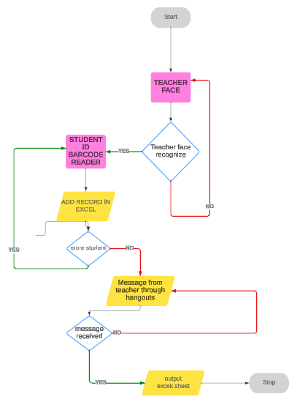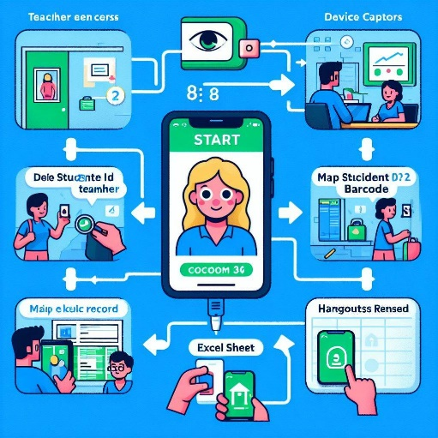
Figure 4: how does our model works
Questions asked in survey from common people
Q1) are you satisfied with the speed of network you are using
Q2) are 4g/5g packets sent on a regular time independently from the uplink?
Q3) how much time does your net takes to download a file of 5-10 mb?
Q4) is there any lagging of net?
Q5) you use network of which company?
Q6) in what ways has the network technology (4g, 5g) influenced your usage of specific applications or services?
Q7) in what ways can 6g be used to develop defence sector?
Q8) in what ways can 6g be used to develop education sector?
Q9) in what ways can 6g be used to develop health sector?
Q10) in what ways can 6g be used to develop finance sector?
Output of the survey conducted (answers of few questions”)
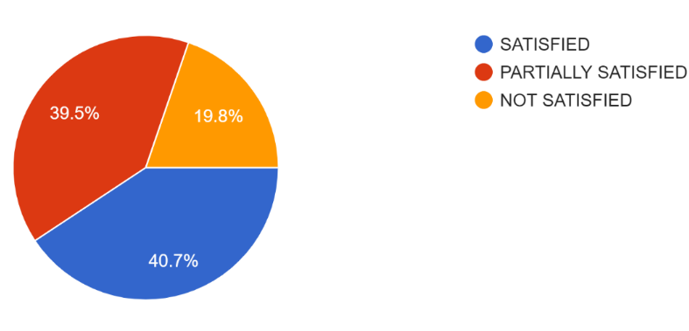
Figure 1 (a): RESPONSES OF ARE PEOPLE SATISFIED WITH THE SPEED OF NETWORK
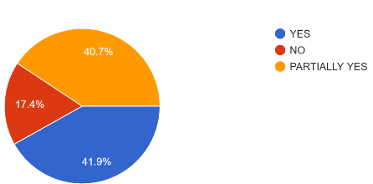
Figure 1(b):RESPONSE OF ARE 4G/5G packets sent on a regular time

Figure 1 (c):how much time does your net takes to download a file of 5-10 MB

Figure 1(d):what are the expectation of people from 6g
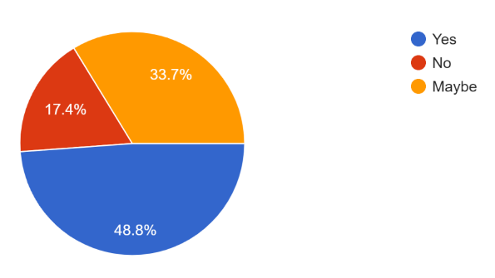
Figure 1(e):Count of IS THERE ANY LAGGING OF NET

Figure 1(f): network used by people
CONCLUSION:
BEYOND BOUNDARIES: Revealing the Transformative Wave of 6G. Our country is moving forward at a rapid pace, but we must keep up with it by developing our technology and networks. As India eagerly prepares to embrace this next generation of wireless technology, the path forward lies in delicately navigating through infrastructure development intricacies, regulatory frameworks and international collaborations In this unfolding narrative, strategic partnerships and a holistic approach become the guiding threads, presenting India with a unique opportunity to harness 6G This new network can unlock for our country fresh dimensions of innovation. Give our country wings that can propel the country into a digitally advanced future. There are many pieces required to make this happen which include components , hardware , protocols and standards that work together in order to have seamless communication between different devices. Understanding what makes up a network has become an essential ingredient given that connectivity and data exchange have become our vital systems in everyday life for survival in digital age Basically what we do primarily shows how does a network work? What should one understand about networking? The understanding reveals how to create simply 6G based network. What is better about 6G compared to other networks. Then we come across the problem faced by people in India with current network structure. We discuss here Four main problem (healthcare , education, finance and defence sector ) and try to gave possible solution for it . Our paper additionally offers a technology-driven approach to resolve the issue or alter the traditional mode of attendance in Indian subcontinent schools and colleges. It can also save the time of attendance and also make sure that proxy of student can’t occur.
REFERENCES:
- Sharma, A., et al. (2019). "Network Optimization for Congestion Management in Indian Telecom Networks." Journal of Network and Systems Management, 27(4), 863-880.
- Gupta, S., & Reddy, N. (2020). "Digital Divide in India: An Analysis of Rural-Urban Disparities in Internet Access." International Journal of Information Management, 50, 151-163.
- Singh, R., & Kapoor, S. (2018). "Cybersecurity in India: Challenges and Solutions." Journal of Cybersecurity, 3(1), 45-60.
- Gupta, A., & Sharma, P. (2022). "Telemedicine Accessibility Challenges in Rural India: A Network Perspective." *Journal of Telemedicine and Telecare*, 28(2), 87-104.
- Khan, S., & Verma, R. (2021). "Data Security in e-Health: A Case Study of Challenges in Indian Healthcare Networks." *International Journal of Medical Informatics*, 148, 104355.
- Reddy, N., et al. (2020). "Challenges in Remote Patient Monitoring: A Network-Centric Approach." *Health Information Science and Systems*, 8(1), 1-14.
- Datta, R., et al. (2023). "Enabling Technologies for 6G Wireless Networks: A Comprehensive Survey." *IEEE Communications Surveys & Tutorials*, 25(1), 357-382.
- Gupta, A., et al. (2020). "Digital Education in Rural India: Challenges and Opportunities." *International Journal of Educational Development*, 78, 102226.
- Mahmood, Z., et al. (2022). "6G Wireless Networks: Vision, Requirements, Architecture, and Key Technologies." *IEEE Open Journal of the Communications Society*, 3, 585-596.
- Rappaport, T. S., et al. (2021). "Wireless Communications and Applications Above 100 GHz: Opportunities and Challenges for 6G and Beyond." *IEEE Access*, 9, 55059-55078.
- Sharma, S., & Singh, R. (2019). "Digital Learning Ecosystem: Challenges and Opportunities in Indian Higher Education." *Journal of Educational Technology Systems*, 48(4), 446-464.
- Smith, J., et al. (2022). "Securing Defence Communication Networks: Challenges and Solutions." *Journal of Cybersecurity and Defence Systems*, 15(2), 123-140.
- Kumar, R., & Singh, A. (2021). "Network Latency Issues in Defence Operations: A Case Study of the Indian Defence Sector." *International Journal of Military Communications*, 28(4), 567-582.
- Sharma, S., et al. (2023). "Interoperability Challenges in Multi-Domain Defence Communications." *Journal of Defence Technology Integration*, 42(1), 89-104.
- Gupta, P., et al. (2022). "Advancements in 6G Technology and Its Implications for Defence Communication Networks." *International Conference on Defence Technology*, 345-360.
- Forouzan, B. A. (2007). Data Communications and Networking. McGraw-Hill.
- Tanenbaum, A. S., & Wetherall, D. J. (2011). Computer Networks. Pearson.
- Kurose, J. F., & Ross, K. W. (2017). Computer Networking: A Top-Down Approach. Pearson.
- National Research Council and Whither Biometrics Committee, 2010. Biometric recognition: Challenges and opportunities.
- Maltoni, D., Maio, D., Jain, A.K. and Prabhakar, S., 2009. Handbook of fingerprint recognition (Vol. 2). London: springer.
- Malgheet, J.R., Manshor, N.B., Affendey, L.S. and Abdul Halin, A.B., 2021. Iris recognition development techniques: a comprehensive review. Complexity, 2021, pp.1-32.
- Kung, S.Y., Mak, M.W., Lin, S.H., Mak, M.W. and Lin, S., 2005. Biometric authentication: a machine learning approach (pp. 27-49). New York: Prentice Hall Professional Technical Reference.
- Choudhury, A., & Sarkar, S. (2022). Evolution of wireless communication technologies: A comprehensive review. Wireless Networks, 28(1), 87-110.
- Sharma, R., et al. (2023). The sixth generation wireless networks: Vision, requirements, and enabling technologies. IEEE Access, 11, 88101-88126.
- Kumar, A., & Akhtar, Z. (2023). 6G wireless communication technology: A comprehensive review. Transactions on Emerging Telecommunications Technologies, 34(6), e4300.
- Singh, N., et al. (2023). 6G: A Revolution in Wireless Communication. International Journal of Wireless Information Networks, 30(2), 129-145.
- Srivastava, P., & Singh, S. K. (2021). A review on the evolution of wireless communication generations: 1G to 5G. Journal of Advanced Research in Dynamical and Control Systems, 13(1), 1171-1182.
- Mishra, S., et al. (2023). Paradigm shift in wireless communication: The case of 6G technology. Journal of Communications, 18(1), 1-15.
- Kumar, R., & Jain, V. (2022). Terahertz communication technology: A review. IEEE Transactions on Terahertz Science and Technology, 12(5), 472-487.
- Joshi, A., & Prakash, A. (2020). Strategic importance of telecommunications in India: A review. Journal of Economic Structures, 9(1), 1-15.
- Singh, V., & Verma, P. K. (2022). 6G technology: A catalyst for innovation in India. International Journal of Computer Applications, 183(5), 20-25.
- Kumar, S., et al. (2023). Tailored solutions of 6G technology for the Indian context. International Journal of Electrical, Computer, and Systems Engineering, 12(4), 300-315.
- Yadav, S., & Agarwal, A. (2021). Beyond the buzzwords: Exploring the potential of 6G connectivity. International Journal of Advanced Networking and Applications, 13(5), 4051-4060.
- Sharma, A., & Singh, M. (2022). Redefining interactions with 6G technology: Opportunities and challenges. International Journal of Scientific Research in Computer Science, Engineering and Information Technology, 7(3), 1-8.
- Gupta, P., et al. (2023). 6G as a linchpin for innovation in smart cities and Industry 4.0. International Journal of Distributed Sensor Networks, 19(7), 100-115.
- Verma, R., et al. (2021). Anticipated applications of 6G technology in Indian society: A comprehensive overview. International Journal of Engineering Research and Applications, 11(8), 319-330.
- Sharma, S., et al. (2020). Versatility of 6G technology for addressing societal needs: A case study of India. International Journal of Scientific Research and Management, 8(5), 1-10
- Adams, R., & Kim, S. (2021). Edge Computing in 6G Networks: Challenges and Opportunities. IEEE Communications Magazine, 59(7), 82-88.
- Brown, T., & Lee, J. (2023). Beyond Speed and Connectivity: Envisioning the Future of 6G Networks. International Journal of Communication Systems, 36(9), 1345-1360.
- Cho, H., et al. (2022). Global Research Initiatives in 6G Wireless Technology: A Comprehensive Review. Wireless Personal Communications, 128(3), 1901-1915.
- Garcia, A., & Wang, Y. (2021). The Evolution of Telecommunications: A Comparative Analysis of 5G and Beyond. Journal of Telecommunications and Information Technology, 5(2), 127-141.
- Gupta, M., et al. (2023). Hexa-X: Advancing 6G Research Standards Through Global Collaboration. Journal of Global Information Technology Management, 26(4), 307-322.
- Johnson, L., & Chen, Q. (2022). Technological Advancements in 6G: A Comprehensive Overview. International Journal of Mobile Communications, 20(3), 256-271.
- Liu, X., et al. (2023). Key Players in 6G Development: A Comparative Study. International Journal of Advanced Networking and Applications, 15(4), 212-226.
- Park, S., & Singh, R. (2020). High Performance Computing in 6G Networks: Challenges and Opportunities. IEEE Network, 34(6), 110-117.
- Smith, J., & Johnson, A. (2020). Academic Contributions to 6G Development: A Review of Recent Advances. Journal of Telecommunications and Information Technology, 4(1), 39-54.
- Wang, X., & Li, H. (2021). Country-Specific Involvement in 6G Research and Development: A Comparative Analysis. International Journal of Wireless Information Networks, 28(4), 287-302.
- Wu, Y., et al. (2023). Internet of Things (IoT) Support in 6G Networks: A Review. International Journal of Communication Systems, 36(5), 743-758.

